COURT FILE NUMBER  Clerk’s Stamp  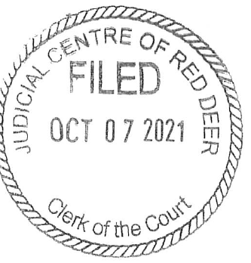 | 4801 12334
COURT | COURT OF QUEEN’S BENCH  OF ALBERTA
JUDICIAL CENTRE | RED DEER
APPLICANT | Mary Smith
RESPONDENT | John Smith
DOCUMENT | ORDER

ADDRESS FOR SERVICE AND
CONTACT INFORMATION OF
PARTY FILING THIS DOCUMENT
 | Mary Smith
 | Box 1234
 | Spruce Grove, Alberta T7X 3A7
 | PHONE: | 780 . 960 . 1234

DATE ON WHICH JUDGMENT WAS GRANTED: July 12, 2021 at Edmonton, Alberta

NAME OF JUDGE WHO GRANTED THIS JUDGMENT: Justice Flinstone

UPON THE application of the Applicant and of the Respondent herein; AND UPON noting the Consent of Counsel for the Applicant and the Respondent herein;

AND UPON the Court being advised that the name and birth date of the child of the marriage is as follows:

Jane Smith, born on November 2, 2014

(the "child")

IT IS HEREBY ORDERED THAT:

- The parties shall have shared parenting time with the child, Jane Smith, on an alternating weekly basis, with the exchange to take place on Fridays after school.

- The Respondent shall pay child support in the amount of $400 per month to the Applicant on the first day of every month commencing August 1, 2021.

___________________________________
Justice of the Court of Queen’s Bench of Alberta

