Form FL-23
[Rule 12.50(3)]

COURT FILE NUMBER | 4803 12524  Clerk’s Stamp  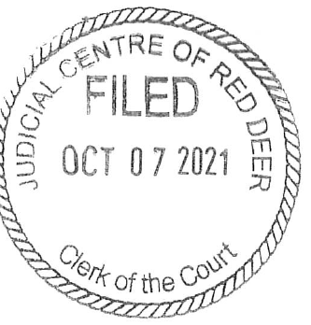
COURT | COURT OF QUEEN’S BENCH OF ALBERTA
JUDICIAL CENTRE | EDMONTON
PLAINTIFF | JOE SMITH
DEFENDANT (Applicant) | MARY SMITH

DOCUMENT | AFFIDAVIT OF MARY SMITH

ADDRESS FOR SERVICE AND
CONTACT INFORMATION OF
PARTY FILING THIS DOCUMENT
 | Mary Smith
 | Box 2222
 | Spruce Grove, Alberta T7X 3A7
 | PHONE: | 780 . 960 . 1234

AFFIDAVIT OF MARY SMITH
Sworn on February 21, 2022
I, Mary Smith, of Edmonton, Alberta, SWEAR AND SAY THAT:

- I am the Defendant (Applicant) in this action and as such, I have a personal knowledge of the facts hereinafter deposed to except where stated to be based on information and belief and where so done, I verily believe it to be true.

- The Plaintiff and I were married on July 5, 2005, and separated in August of 2021. There are two children of the marriage, Jane Smith, born on August 10, 2007, and Daniel Smith, born on March 15, 2010.

- The Plaintiff moved out of the family home in August 2021, and the children have resided with me since then. The children spend time with him every second weekend.

- Before our first child was born, I had various low paying jobs, including working in a restaurant, cashier, and receptionist. I stopped working shortly before Jane was born and have not worked outside of the home since.

- The Plaintiff has been employed as an engineer for the same company for several years, and earns approximately $150,000 per year.

- In order to get a decent paying job, I want to take the Legal Assistant program at NAIT. In order to do so, I need both child support and spousal support from the Plaintiff.

- I make this affidavit in support of my application for child and spousal support.

SWORN BEFORE ME at Spruce Grove, )
Alberta, this 21st day of |February, 2022 )
)
) ______________________________
__________________________________ ) Mary Smith
A COMMISSIONER FOR OATHS
In and for the Province of Alberta

